III B. Tech I Semester Regular Examinations – November, 2024
Introduction to Artificial Intelligence
Time: 120 Min (CSE) Max. Marks:60M

SECTION – A
Answer all Four questions 4×8M=32M

- a) Differentiate intelligence, artificial intelligence, and rationality. How can we define "rationality" in the context of AI, given that emotions, biases, and incomplete information often influence human rationality? Should AI aim to replicate human rationality or strive for an "ideal" form of rational decision-making? [2M]
b) Imagine a healthcare AI system designed to assist doctors in diagnosing and prioritizing treatments for patients in a high-demand emergency room. The AI is programmed to assess each patient's symptoms, medical history, and urgency level to recommend optimal treatment paths and care orders. [3M]
The system encounters two patients who need urgent attention:
- Patient A, an elderly individual with a complex medical history, statistically has a lower chance of full recovery but requires extensive resources.
- Patient B is a young adult with a high probability of survival and less resource-intensive needs.
How should the AI system apply "intelligence" and "rationality" to prioritize treatment in this scenario? Should it prioritize Patient B due to a higher survival probability (a rational decision based on efficiency) or Patient A, recognizing that all lives hold equal ethical value (an intelligent decision that respects ethical norms)? What frameworks or principles should guide AI in balancing the rational allocation of resources with the intelligent assessment of ethical considerations?
c) You have four jugs with capacities of 3 liters, 5 liters, 8 liters, and 10 liters, but none have any measurement marks. Only the 10-liter jug is initially filled with water, while the others are empty. Your goal is to use these jugs to measure exactly 4 liters in either of them. You may transfer water between the jugs but can only pour until a jug is empty or full.
What sequence of moves will allow you to measure exactly 4 liters in one of the jugs? [3M]

- a) Compare informed and uninformed search strategies. In the context of search algorithms used in artificial intelligence, how do the fundamental differences between informed and uninformed search strategies impact their efficiency and effectiveness in solving problems, particularly in complex environments with vast search spaces? [2M]
b) How could Breadth-First Search (BFS) and Uniform Cost Search (UCS) be applicable for pathfinding in weighted graphs, and how can the characteristics of each algorithm be combined to optimize performance in terms of time and space complexity? Specifically, what strategies can be employed to leverage BFS’s completeness and lower memory usage while incorporating UCS’s ability to find the least-cost path, and in what types of problems or environments would such a hybrid approach be most beneficial? [3M]
c) Apply both the Breadth-First Search (BFS) and Uniform Cost Search (UCS) techniques on a given graph [3M]
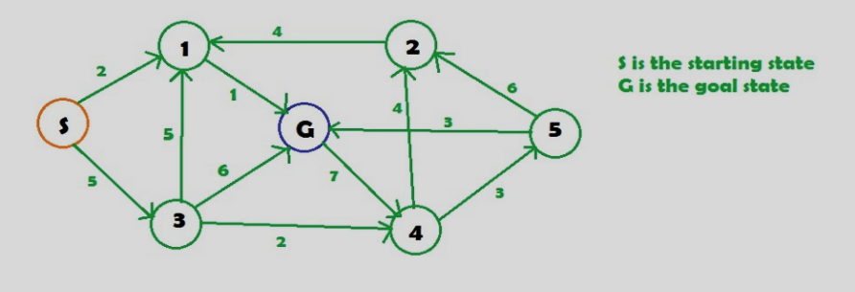

- a) Differentiate the words Data and Knowledge with real-time examples. [2M]
b) Consider the following Zombie Apocalypse World. In this World, an agent (survivor) must navigate through a grid-based environment to reach a designated Safe Zone while avoiding dangerous cells occupied by Zombies. The agent must also deal with obstacles, such as Trees, which may block its view and restrict movement. [6M]
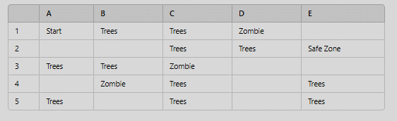

The agent must use logical reasoning to deduce where zombies are located and, based on its observations, plan a safe path to the Safe Zone.
- What are the key components of the Zombie Apocalypse World environment?
- How does the Zombie Apocalypse World demonstrate the principles of a Knowledge-Based Agent (KBA)?
- Express the generated facts using formal logic representation.
- Use inference and resolution techniques to conclude the given sentences.

- What is Learning in the context of AI? An autonomous customer service AI system is being developed for a large e-commerce platform to handle tasks like customer sentiment analysis, user clustering for personalized recommendations, and an interactive chatbot that learns to assist users with their queries. The AI system has three main tasks: [3M+3M+2M]
- Sentiment Analysis: The AI system analyses customer reviews to classify them as positive, neutral, or negative based on labeled historical data from customer reviews.
- User Segmentation: The AI system groups users into segments based on browsing behavior, purchase history, and interaction time on different product categories. There are no predefined labels for these user segments, and the system needs to find patterns in user behavior data.
- Interactive Chatbot: The AI system interacts with customers through a chatbot interface, responding to their questions and providing recommendations. The chatbot receives positive feedback (reward) when customers complete a purchase following a recommendation and negative feedback (penalty) when the customer exits the chat without buying or getting a helpful answer. The chatbot aims to optimize its responses over time to maximize successful interactions.
- Identify the Learning Type and justify your answer by explaining the core characteristics of each learning type in the task context.
- Analyse how the type of data and feedback provided to the AI system differs between
these three types of learning.
- Apply the training process involved in each learning and mention the company's challenges in each task.

SECTION - B
Answer all Two questions 2×14M=28M

- a) Describe any two types of AI agents and give an example application for each. Explain how each type of agent would handle a situation in a dynamic environment like autonomous driving [3M]
b) Explain the primary differences between Best-First Search (BFS) and A* Search regarding their approach to finding a path to a goal. Describe how each algorithm evaluates nodes and chooses the next node to expand. [4M]
c) Assume (or) imagine a grid-based environment with obstacles and variable terrain costs, discuss whether Best-First Search with a heuristic based on straight-line (Euclidean) distance is guaranteed to find the optimal path from a start node S to a goal node G. Justify your answer concerning BFS’s evaluation function and its implications, for the same environment, and explain how A* Search uses both the actual path cost and a heuristic to guide its search. What conditions on the heuristic function h(n) are necessary to guarantee that A* will find the optimal path? Provide a brief explanation of why these conditions are essential. [5M]
d) Suppose you are tasked with choosing between BFS and A* for a pathfinding problem on a large grid. Discuss the scenarios in which you would prefer each algorithm, considering factors like optimality, computational efficiency, and memory usage. [2M]

- a) What is planning in the context of Artificial Intelligence? [2M]
b) Consider a vehicle that carries a spare tire and needs to travel from a start location to a destination, crossing a desert area without access to additional resources. The vehicle has a limited number of tires (including the spare) and is at risk of tire punctures along the way. Design how you would model this problem in terms of planning for potential failures. [5M]
c) Explain Decision Tree Induction with an example. [2M]
d) Consider a dataset of loan applications from a financial institution. Each record includes information about applicants: age, credit score, annual income, employment status, loan amount requested, and prior repayment history. You are tasked with building a decision tree to predict whether a loan application will be approved (yes/no). The dataset contains numerical and categorical attributes; some records have missing values.
Design an algorithm to construct an effective decision tree model that addresses issues such as handling missing values, selecting optimal splitting criteria, and managing both categorical and numerical attributes. [5M]

